**Effect of Current Smoking Status and Age on Satisfaction with Physical Ability after 12 Months of Lifestyle Intervention Program**

3/31/2024, Kath Fillman

**Introduction.**  A four year randomized clinical trial focused on the efficacy of nonpharmacologic approaches for the treatment of stage 1 hypertension that used a lifestyle intervention program and drug therapy to gather data on the effects of weight loss on participant's indicators of health, including their satisfaction with their physical ability at 12 months. This analysis aimed to determine the effect of a participant's age and smoking status on the participants’ self-reported satisfaction score.

**Dataset.** The dataset tomhs.csv was provided by the instructor. It contained data from 902 participants (234 placebo, 668 treatment) in 126 categories including the clinic they were treated at, study group, age at beginning of study, sex, race, smoking status, weight, blood pressure, total cholesterol, and blood glucose. The main variable of interest was their satisfaction with physical ability at 12 months rated on a score of 1-6 with the descriptions being Completely Satisfied (1), Very Satisfied (2), Somewhat Satisfied (3), Somewhat Dissatisfied (4), Very Dissatisfied (5), and Completely Dissatisfied (6). Other variables of interest include their age and rather or not they currently smoke. Not all participants responded to the satisfaction question (844) and rather or not they are current smokers (424).

**Exploratory Data Analysis.** Participant satisfaction at 12 months had a mean of 2.05, which is closest to the Very Satisfied rating. The data had a standard deviation of 0.89 and a skew of 0.88 (table 1). This data has a right skew, which can be seen in figure 1. The majority of participants seem to rate their satisfaction with their physical abilities as Completely Satisfied (fig. 1). Participant ages had a mean of 54.77 and a standard deviation of 6.4 years (table 1). Ages ranged from 45 to 69 years old and had a noticeable right skew of 0.28 (fig. 2, table 1). Current Smoking status showed the majority of participants were not current smokers (fig. 3). 96 participants identified as current smokers (table 2).

**Methods.** Ordinal regression was used to determine the effect of current smoking status and age on satisfaction with physical ability at 12 months. P-values less than 0.05 were significant. All analyses were performed in R-studio version 2023.12.1, build 402.

**Results.** The results of the adjusted model are shown in table 3. The common odds ratio for age is 0.9971 with a 95% confidence interval of 0.9692, 1.0258. The common odds ratio for smoking status is 1.5355 with a confidence interval of 0.9742, 2.4238 (table 3). Neither of these results are seen as statistically significant as both their confidence intervals include 1.

**Conclusions.**

There is no evidence of an age or smoking status effect on a participant's self-reported satisfactions with their physical ability after 12 months of this lifestyle intervention program.

**Appendix**

**Table 1. Summary Statistics for Participant Satisfaction at 12 Months and Age**

|  | mean | sd | skew |
| --- | --- | --- | --- |
| Participant Satisfaction at 12 Months | 2.05 | 0.89 | 0.88 |
| Participant Age | 54.77 | 6.4 | 0.28 |

**Table 2. Participant Satisfaction at 12 Months by Smoking Status**

| Smoking Status | 1 | 2 | 3 | 4 | 5 | 6 | Total |
| --- | --- | --- | --- | --- | --- | --- | --- |
| Current Smoker | 22 | 32 | 25 | 5 | 2 | 1 | 96 |
| Not a Current Smoker | 89 | 139 | 61 | 13 | 3 | 1 | 326 |

**Table 3. Model Outcomes**

| Effect of Current Smoking Status and Age on Satisfaction with Physical Ability after 12 Months of Lifestyle Intervention Program | | |
| --- | --- | --- |
|  | **Common Odds Ratio** | **95% Confidence Interval** |
| **Age** | 0.9971 | 0.9692, 1.0258 |
| **Smoking Status** | 1.5355 | 0.9742, 2.4238 |

**Figure 1. Figure 2.**

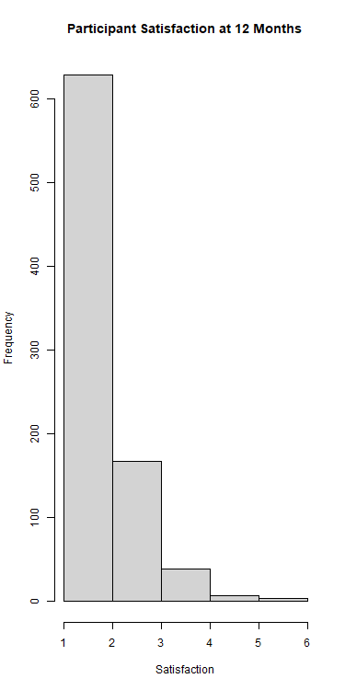 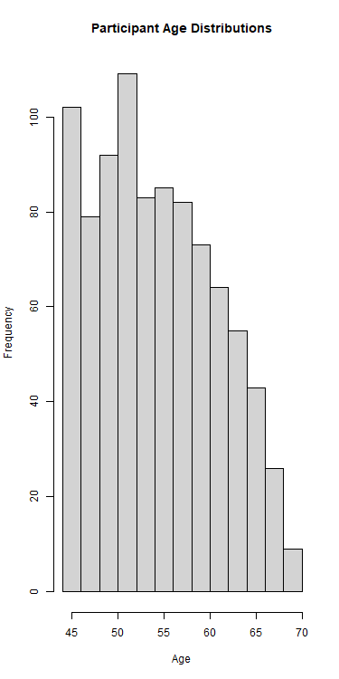

**Figure 3.**

